Name: _________________________________________________________ Date: _________________
VOLUME OF PRISMS
The total space inside of a 3D figure is the VOLUME of an object. Volume is measured in cubic units.
Volume is the number of cubic units it would take to completely fill up this rectangular prism!
1 cubic unit

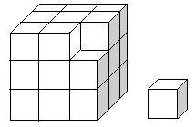
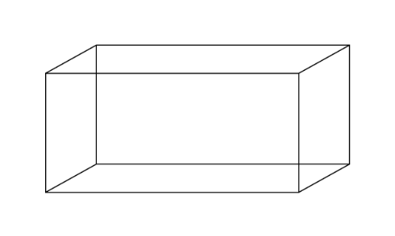
To find the volume of a rectangular prism, we have to see how many cubic units fit inside the shape.
You use your knowledge of area of the base (which is 2-dimensional), but must also use the height of the solid.
Area of 2D rectangle: Length $∙$ Width
L $∙$ W

Volume formula
V= L $∙$ W $∙$ H
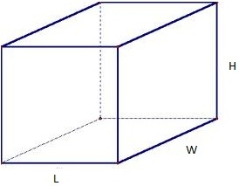

Example: Find the volume.
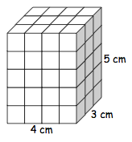
V= L $∙$ W $∙$ H
V= 4 $∙$ 3 $∙$ 5
V= 12 $∙$ 5
V= 60 ${cm}^{3}$

Let’s Practice:
- Count the units and label the length, width, and height of the rectangular prism shown. Use those measurements to calculate how many cubic units make up the prism. Use the Volume formula.
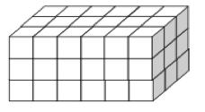 V= _______ ${units}^{3}$

- This rectangular prism does not show the individual cubic units, but you can still find volume by substituting the length, width, and height into the formula!
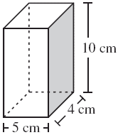V= ______ ${cm}^{3}$

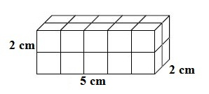 V= ________

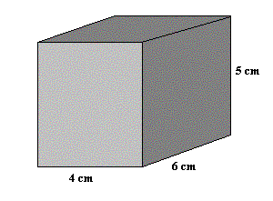 V= ________

