COMMUNICATION
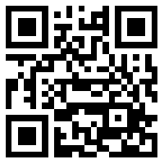
bmsgibbs.weebly.com
This is the URL for our class website. Posts will include assignment reminders, links to worksheets or online resources, and important announcements. You can also scan the QR code above for direct access.
______________________________________________________________________________
We will also be using a texting platform called REMIND for reminders, announcements, notes of encouragement, etc.
Please read the Q&A below for more information. REMIND is commonly used in classrooms and provides a secure and safe way for teachers and students to communicate.
How to join Mrs. Gibbs’s REMIND group
- Scan the QR code and input name and phone number.
OR
- Text @bmsgibbs to the number 81010 or to (606)619-4083
- You will receive a welcome message from REMIND once you have successfully joined the group!
